**Project Report**

**Title:SHOPPING WEBSITE**

## BACHELOR OF TECHNOLOGY

Computer science and Engineering

Submitted to

## Ms. Nausheen Fatima

**LOVELY PROFESSIONAL UNIVERSITY PHAGWARA, PUNJAB**

**SUBMITTED BY :- ANANT TYAGI** **Reg***.***No:- 12206765 Roll No:-25**

# ACKNOWLEDGEMENT



Primarily I would like to thank God for being able to learn a new technology. Then I would like to express my special thanks of gratitude to the teacher who provide me the golden opportunity to learn a new technology .

I would like to also thank my own college Lovely Professional University for offering such a course

which not only improve my programming skill but also taught me other new technology.

Then, I would like to thank my parents and friends who have helped me with their valuable suggestions and guidance for choosing this course.

I am making this project not only for marks but to also increase my knowledge.

THANKS AGAIN TO ALL

***DESIGN AND SOURCE CODE:-***

**LOGIN PAGE**

**SOURCE CODE -:**

**<HTML>**

**<!**DOCTYPE *html***>**

**<**html *lang*="en" *dir*="ltr"**>**

**<**head**>**

**<**meta *charset*="utf-8"**>**

**<**title**>**login.shop**</**title**>**

**<**link *rel*="stylesheet" *href*="style.css"**>**

**<**style**>**

        *{

  margin: 0;

  padding: 0;

  box-sizing: **border-box**;

  font-family: 'Poppins', **sans-serif**;

}

html,body{

  display: **grid**;

  height: 100%;

  width: 100%;

  place-items: **center**;

  <bg-image

}

*::selection*{

  background: **#438ab6**;

  color: rgb(237, 231, 231);

}

*.wrapper*{

  width: 380px;

  background: rgb(252, 252, 250);

  border-radius: 20px;

  box-shadow: 0px 15px 20px rgba(58, 9, 9, 0.1);

}

*.wrapper* *.title*{

  font-size: 35px;

  font-weight: 600;

  font-style: **oblique**;

  text-align: **center**;

  line-height: 100px;

  color: rgb(248, 245, 245);

  user-select: **none**;

  border-radius: 15px 15px 0 0;

background: linear-gradient(-135deg, **#1842c2**, **#0cba9a**);

}

*.wrapper* form{

  padding: 10px 30px 50px 30px;

}

*.wrapper* form *.field*{

  height: 50px;

  width: 100%;

  margin-top: 20px;

  position: **relative**;

}

*.wrapper* form *.field* input{

  height: 100%;

  width: 100%;

  outline: **none**;

  font-size: 17px;

  padding-left: 20px;

  border: 1px **solid** **lightgrey**;

  border-radius: 25px;

  transition: **all** 0.3s **ease**;

}

*.wrapper* form *.field* input*:focus*,

form *.field* input*:valid*{

  border-color: **#4158d0**;

}

*.wrapper* form *.field* label{

  position: **absolute**;

  top: 50%;

  left: 20px;

  color: **#999999**;

  font-weight: 400;

  font-size: 17px;

  pointer-events: **none**;

  transform: translateY(-50%);

  transition: **all** 0.3s **ease**;

}

form *.field* input*:focus* ~ label,

form *.field* input*:valid* ~ label{

  top: 0%;

  font-size: 16px;

  color: **#4158d0**;

  background: **#fff**;

  transform: translateY(-50%);

}

form *.content*{

  display: **flex**;

  width: 100%;

  height: 50px;

  font-size: 16px;

  align-items: **center**;

**RESULT/OUTPUT-:**

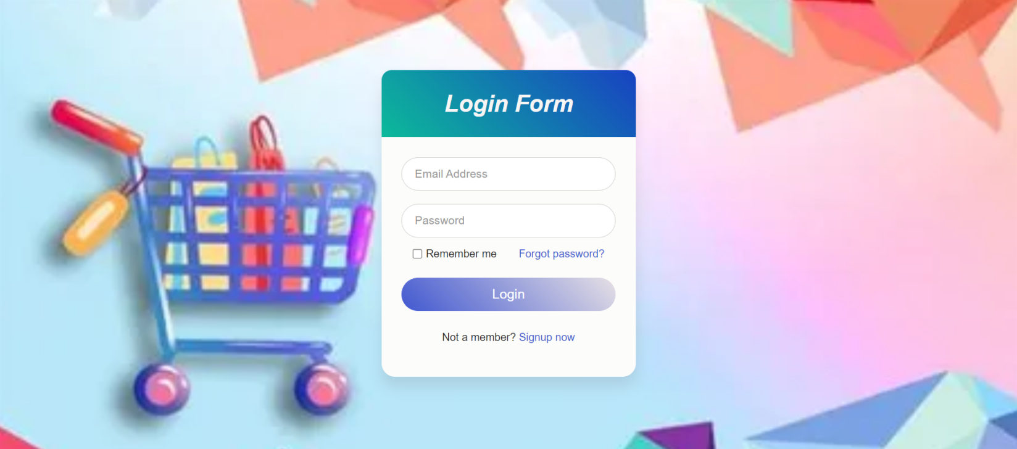

**HOME PAGE//**

**SOURCE CODE-:**

**<HTML>**

**<!**DOCTYPE *html***>**

**<**html *lang*="en"**>**

**<**head**>**

**<**meta *charset*="UTF-8" **/>**

**<**meta *name*="viewport" *content*="width=device-width, initial-scale=1.0" **/>**

***<!--*** Boxicons ***-->***

**<**link *href*="https://unpkg.com/boxicons@2.0.7/css/boxicons.min.css" *rel*="stylesheet" **/>**

***<!--*** Fontawesome ***-->***

**<**link *rel*="stylesheet" *href*="https://cdnjs.cloudflare.com/ajax/libs/font-awesome/5.15.1/css/all.min.css"**>**

***<!--*** Custom StyleSheet ***-->***

**<**link *rel*="stylesheet" *href*="./xyz.css" **/>**

**<**title**>** E STORE**</**title**>**

**</**head**>**

**<**body**>**

***<!--*** HEADER ***-->***

**<**header *class*="header"**>**

**<**nav**>**

**<**img *src*="images/shopping logo.webp"  *class*="logob"**>**

**<**ul**>**

**<**li**><**a *href*=""**>**HOME**</**a**></**li**>**

**<**li**><**a *href*=""**>**ABOUT US**</**a**></**li**>**

**<**li**><**a *href*=""**>**CONTACT US**</**a**></**li**>**

**</**ul**>**

**</**nav**>**

***<!--*** Intro ***-->***

**<**div *class*="intro"**>**

**<**h1**>**TRY OUT THESE LEATHER PRODUCTS**</**h1**>**

**<**h2**>**

            Up to**</**br**>**

**<**span *class*="dis"**>**30%

              Discount**</**span**></**br**>**

            on This **<**br **/>**

            New Year Season

**</**h2**>**

**<**h3**>**From 1st Jan to 31st Jan**</**h3**>**

**<**a *href*="#" *class*="btn"**>**SHOP NOW**</**a**>**

**</**div**>**

**</**header**>**

**<**section *class*="section benefits"**>**

**<**div *class*="benefit-center box"**>**

**<**div *class*="benefit"**>**

**<**span *class*="icon"**><**i *class*="bx bx-purchase-tag"**></**i**></**span**>**

**<**h4**>**Free Shipping**</**h4**>**

**<**span *class*="text"**>**Capped at $16 per order**</**span**>**

**</**div**>**

**<**div *class*="benefit"**>**

**<**span *class*="icon"**><**i *class*="bx bx-book-reader"**></**i**></**span**>**

**<**h4**>**10-Day Returns**</**h4**>**

**<**span *class*="text"**>**Shop without any fear**</**span**>**

**</**div**>**

**<**div *class*="benefit"**>**

**<**span *class*="icon"**><**i *class*="bx bx-headphone"**></**i**></**span**>**

**<**h4**>**24/7 Support**</**h4**>**

**<**span *class*="text"**>**We are always there to help you**</**span**>**

**</**div**>**

**</**div**>**

**</**section**>**

***<!--*** New Arrivals ***-->***

**<**section *class*="section"**>**

**<**div *class*="h"**>**

**<**h1**><**span**>**New**</**span**>** Arrivals**</**h1**>**

**</**div**>**

**<**div *class*="ac-center box"**>**

**<**div *class*="ac"**>**

**<**div *class*="img-cover"**>**

**<**img *src*="images/jackets.webp" *alt*="" **/>**

**</**div**>**

**<**p**>**+Jackets**</**p**>**

**<**div *class*="rating"**>**

**<**i *class*="bx bxs-star"**></**i**>**

**<**i *class*="bx bxs-star"**></**i**>**

**<**i *class*="bx bxs-star"**></**i**>**

**<**i *class*="bx bxs-star"**></**i**>**

**<**i *class*="bx bxs-star"**></**i**>**

**</**div**>**

**<**div *class*="price"**>**₹ 5000**</**div**>**

**</**div**>**

**<**div   *class*="ac"**>**

**<**div *class*="img-cover"**>**

**<**img *src*="images/WHBag.webp" *alt*="" **/>**

**</**div**>**

**<**p**>**Women Hand Bag**</**p**>**

**<**div *class*="rating"**>**

**<**i *class*="bx bxs-star"**></**i**>**

**<**i *class*="bx bxs-star"**></**i**>**

**<**i *class*="bx bxs-star"**></**i**>**

**<**i *class*="bx bxs-star"**></**i**>**

**<**i *class*="bx bx-star"**></**i**>**

**</**div**>**

**<**div *class*="price"**>**₹ 3000**</**div**>**

**</**div**>**

**<**div *class*="ac"**>**

**<**div *class*="img-cover"**>**

**<**img *src*="images/garic fox.webp" *alt*="" **/>**

**</**div**>**

**<**p**>**Arctic fox bag **</**p**>**

**<**div *class*="rating"**>**

**<**i *class*="bx bxs-star"**></**i**>**

**<**i *class*="bx bxs-star"**></**i**>**

**<**i *class*="bx bxs-star"**></**i**>**

**<**i *class*="bx bxs-star"**></**i**>**

**<**i *class*="bx bx-star"**></**i**>**

**</**div**>**

**<**div *class*="price"**>**₹ 2000**</**div**>**

**</**div**>**

**<**div *class*="ac"**>**

**<**div *class*="img-cover"**>**

**<**img *src*="images/headphone.webp" *alt*="" **/>**

**</**div**>**

**<**p**>**Boat Headphones**</**p**>**

**<**div *class*="rating"**>**

**<**i *class*="bx bxs-star"**></**i**>**

**<**i *class*="bx bxs-star"**></**i**>**

**<**i *class*="bx bxs-star"**></**i**>**

**<**i *class*="bx bxs-star"**></**i**>**

**<**i *class*="bx bx-star"**></**i**>**

**</**div**>**

**<**div *class*="price"**>**₹ 1500**</**div**>**

**</**div**>**

**</**div**>**

**</**section**>**

***<!--*** Shop By Category ***-->***

**<**section *class*="section"**>**

**<**div *class*="h"**>**

**<**h1**><**span**>**Shop By**</**span**>** Categories**</**h1**>**

**</**div**>**

**<**div *class*="ab box"**>**

**<**div *class*="item item-1"**>**

**<**img *src*="images/cloth.webp" *alt*="" **/>**

**</**div**>**

**<**div *class*="item item-2"**>**

**<**img *src*="images/trouser.webp" *alt*="" **/>**

**</**div**>**

**<**div *class*="item item-3"**>**

**<**img *src*="images/laptop.webp" *alt*="" **/>**

**</**div**>**

**<**div *class*="item item-4"**>**

**<**img *src*="images/home.webp" *alt*="" **/>**

**</**div**>**

**</**div**>**

**</**section**>**

***<!--*** Popular Products ***-->***

**<**section *class*="section"**>**

**<**div *class*="h"**>**

**<**h1**>**Popular **<**span**>**Products**</**span**></**h1**>**

**</**div**>**

**<**div *class*="ac-center box"**>**

**<**div *class*="ac"**>**

**<**div *class*="img-cover"**>**

**<**img *src*="images/hoddy.webp" *alt*="" **/>**

**</**div**>**

**<**p**>**jackets**</**p**>**

**<**div *class*="rating"**>**

**<**i *class*="bx bxs-star"**></**i**>**

**<**i *class*="bx bxs-star"**></**i**>**

**<**i *class*="bx bxs-star"**></**i**>**

**<**i *class*="bx bxs-star"**></**i**>**

**<**i *class*="bx bx-star"**></**i**>**

**</**div**>**

**<**div *class*="price"**>**₹ 8500**</**div**>**

**</**div**>**

**<**div *class*="ac"**>**

**<**div *class*="img-cover"**>**

**<**img *src*="images/t shirt.webp" *alt*="" **/>**

**</**div**>**

**<**p**>**T-shirt**</**p**>**

**<**div *class*="rating"**>**

**<**i *class*="bx bxs-star"**></**i**>**

**<**i *class*="bx bxs-star"**></**i**>**

**<**i *class*="bx bxs-star"**></**i**>**

**<**i *class*="bx bxs-star"**></**i**>**

**<**i *class*="bx bx-star"**></**i**>**

**</**div**>**

**<**div *class*="price"**>**₹ 5000**</**div**>**

**</**div**>**

**<**div *class*="ac"**>**

**<**div *class*="img-cover"**>**

**<**img *src*="images/milton.webp" *alt*="" **/>**

**</**div**>**

**<**p**>**Milton bottle**</**p**>**

**<**div *class*="rating"**>**

**<**i *class*="bx bxs-star"**></**i**>**

**<**i *class*="bx bxs-star"**></**i**>**

**<**i *class*="bx bxs-star"**></**i**>**

**<**i *class*="bx bxs-star"**></**i**>**

**<**i *class*="bx bx-star"**></**i**>**

**</**div**>**

**<**div *class*="price"**>**₹ 1200**</**div**>**

**</**div**>**

**<**div *class*="ac"**>**

**<**div *class*="img-cover"**>**

**<**img *src*="images/smartphone.webp" *alt*="" **/>**

**</**div**>**

**<**p**>**Smartphones**</**p**>**

**<**div *class*="rating"**>**

**<**i *class*="bx bxs-star"**></**i**>**

**<**i *class*="bx bxs-star"**></**i**>**

**<**i *class*="bx bxs-star"**></**i**>**

**<**i *class*="bx bxs-star"**></**i**>**

**<**i *class*="bx bx-star"**></**i**>**

**</**div**>**

**<**div *class*="price"**>**₹12,000**</**div**>**

**</**div**>**

**<**div *class*="ac"**>**

**<**div *class*="img-cover"**>**

**<**img *src*="images/shoes.webp" *alt*="" **/>**

**</**div**>**

**<**p**>**Shoes**</**p**>**

**<**div *class*="rating"**>**

**<**i *class*="bx bxs-star"**></**i**>**

**<**i *class*="bx bxs-star"**></**i**>**

**<**i *class*="bx bxs-star"**></**i**>**

**<**i *class*="bx bxs-star"**></**i**>**

**<**i *class*="bx bx-star"**></**i**>**

**</**div**>**

**<**div *class*="price"**>**₹ 3200**</**div**>**

**</**div**>**

**<**div *class*="ac"**>**

**<**div *class*="img-cover"**>**

**<**img *src*="images/wallet.webp" *alt*="" **/>**

**</**div**>**

**<**p**>**women hand bags **</**p**>**

**<**div *class*="rating"**>**

**<**i *class*="bx bxs-star"**></**i**>**

**<**i *class*="bx bxs-star"**></**i**>**

**<**i *class*="bx bxs-star"**></**i**>**

**<**i *class*="bx bxs-star"**></**i**>**

**<**i *class*="bx bx-star"**></**i**>**

**</**div**>**

**<**div *class*="price"**>**₹ 1600**</**div**>**

**</**div**>**

**<**div *class*="ac"**>**

**<**div *class*="img-cover"**>**

**<**img *src*="images/women sandal.webp" *alt*="" **/>**

**</**div**>**

**<**p**>**sandals**</**p**>**

**<**div *class*="rating"**>**

**<**i *class*="bx bxs-star"**></**i**>**

**<**i *class*="bx bxs-star"**></**i**>**

**<**i *class*="bx bxs-star"**></**i**>**

**<**i *class*="bx bxs-star"**></**i**>**

**<**i *class*="bx bx-star"**></**i**>**

**</**div**>**

**<**div *class*="price"**>**₹ 600**</**div**>**

**</**div**>**

**<**div *class*="ac"**>**

**<**div *class*="img-cover"**>**

**<**img *src*="images/belt.webp" *alt*="" **/>**

**</**div**>**

**<**p**>**Belt**</**p**>**

**<**div *class*="rating"**>**

**<**i *class*="bx bxs-star"**></**i**>**

**<**i *class*="bx bxs-star"**></**i**>**

**<**i *class*="bx bxs-star"**></**i**>**

**<**i *class*="bx bxs-star"**></**i**>**

**<**i *class*="bx bx-star"**></**i**>**

**</**div**>**

**<**div *class*="price"**>**₹ 500**</**div**>**

**</**div**>**

**</**div**>**

**</**section**>**

***<!--***---footer------------------***-->***

**<**section *id*="footer"**>**

**<**div *class*="foot"**>**

**<**ul**>**

**<**li**><**a *href*=""**>**HOME**</**a**></**li**>**

**<**li**><**a *href*=""**>**ABOUT US**</**a**></**li**>**

**<**li**><**a *href*=""**>**CONTACT US**</**a**></**li**>**

**</**ul**>**

**<**div *class*="social-links"**>**

**<**a *href*=""**><**i *class*="fab fa-linkedin"**></**i**></**a**>**

**<**a *href*=""**><**i *class*="fab fa-behance"**></**i**></**a**>**

**<**a *href*=""**><**i *class*="fab fa-dribbble"**></**i**></**a**>**

**<**a *href*=""**><**i *class*="fab fa-instagram"**></**i**></**a**>**

**</**div**>**

**</**div**>**

**</**section**>**

**</**body**>**

**</**html**>**

**<CSS>**

*,

\**::before*,

\**::after* {

  margin: 0;

  padding: 0;

  box-sizing: **inherit**;

}

html {

  box-sizing: **border-box**;

  font-size: 70%;

}

body {

  font-family: "Poppins", **sans-serif**;

  font-size: 18px;

  color: **black**;

  background-color: **whitesmoke**;

}

img {

  max-width: 100%;

}

*.box* {

  max-width: 1824px;

  margin: 0 **auto**;

}

*@media* only **screen** and (max-width: 1200px) {

*.box* {

    padding: 0 48px;

  }

}

***/\**** HEADER ***\*/***

*.logob*{

 width: 100px;

 height: 80px;

 cursor: **pointer**;

 }

 nav{

  width: 84%;

  margin: **auto**;

  padding: 20px 0;

  display: **flex**;

  align-items: **center**;

  justify-content: **space-between**;

 }

 nav ul li{

     display: **inline-block**;

     list-style: **none**;

     margin: 10px 20px;

 }

 nav ul li a{

     text-decoration: **none**;

     color: **#606163**;

 }

 nav ul li a*:hover*{

     color: **#ff4321**;

 }

*.d* {

  display: **flex**;

  align-items: **center**;

}

*.align-center* {

  display: **flex**;

  align-items: **center**;

  justify-content: **center**;

}

*@media* only **screen** and (max-width: 768px) {

  nav {

    padding: 16px 0;

  }

*.icons*{

    display: **none**;

  }

*.logob*{

    width: 100px;

    height: 80px;

    cursor: **pointer**;

    }

  }

***/\**** Intro ***\*/***

*.intro* {

  height: calc(100vh - 112px);

  overflow: **hidden**;

  position: **relative**;

  z-index: 0;

  background-color: **lightgray**;

  background-image: url('wallet1.jpg');

  background-repeat: **no-repeat**;

  background-attachment: **scroll**;

  background-size: 100% 100%;

***/\****background-blend-mode: overlay;***\*/***

}

*.intro-content* {

  height: 100%;

}

*.dis* {

  display: **inline-block**;

  font-size: 40px;

  color: **#ff4321**;

}

*.intro* h1 {

  margin-top: 50px;

  line-height: 1.3;

  font-weight: 600;

  font-size: 50px;

  text-align: **center**;

}

*.intro* h2 {

  line-height: 1.3;

  font-weight: 600;

  font-size: 45px;

  text-align: **center**;

}

*.intro*  h3 {

  font-weight: 400;

  font-size: 40px;

  text-align: **center**;

}

*.btn* {

  display: **inline-block**;

  border-radius: 80px;

  background-color: **#ff4321**;

  padding: 20px 80px;

  color: **white**;

  font-weight: 600;

  box-shadow: 0 16px 24px rgba(0, 0, 0, 0.3);

  margin-top: 75px;

  margin-left: 600px;

}

***/\**** Section ***\*/***

*.section* {

  padding: 160px 0 0 0;

}

***/\**** Benefits ***\*/***

*.benefit-center* {

  display: **grid**;

  grid-template-columns: repeat(**auto-fit**, minmax(240px, 1fr));

  gap: 80px;

}

*.benefit* {

  border: 1px **solid** **#ccc**;

  padding: 16px 16px 32px 16px;

  display: **flex**;

  align-items: **center**;

  flex-direction: **column**;

}

*.benefit* *.icon* {

  color:  **#ff4321**;

  font-size: 64px;

}

*.benefit* h4 {

  margin-bottom: 5px;

}

*.benefit* *.text* {

  font-size: 24px;

  color: **#777**;

}

***/\**** New Arrivals ***\*/***

*.h* {

  font-size: 3rem;

  text-align: **center**;

  margin-bottom: 5rem;

  font-weight: 600;

}

*.h* h1 {

  font-weight: 400;

}

*.h* span {

  color:  **#ff4321**;

}

*.ac-center* {

  display: **grid**;

  grid-template-columns: repeat(**auto-fit**, minmax(320px, 1fr));

  gap: 80px;

  margin-bottom: 80px;

}

*.ac* {

  text-align: **center**;

  padding-bottom: 16px;

  transition: **all** 500ms **ease-in-out**;

}

*.ac:hover* {

  box-shadow: 0 5px 10px rgba(0, 0, 0, 0.1);

}

*.ac* *.img-cover* {

  overflow: **hidden**;

}

*.ac* img {

  transition: **all** 500ms **ease-in-out**;

}

*.ac:hover* img {

  transform: scale(1.2);

}

*@media* only **screen** and (max-width: 567px) {

*.h* {

    font-size: 32px;

  }

}

*.ab* {

  display: **grid**;

  grid-template-columns: repeat(6, 1fr);

  grid-template-rows: repeat(8, 4vw);

  gap: 2rem;

}

*.ab* *.item* {

  overflow: **hidden**;

}

*.ab* img {

  object-fit: **cover**;

  height: 100%;

  width: 100%;

  transition: **all** 500ms **ease-out**;

}

*.ab* *.item-1* img {

  object-fit: **fill**;

}

*.ab* img*:hover* {

  transform: scale(1.2);

}

*.item-1* {

  grid-column-start: 1;

  grid-column-end: 3;

  grid-row-start: 1;

  grid-row-end: 9;

}

*.item-2* {

  grid-column-start: 5;

  grid-column-end: 7;

  grid-row-start: 1;

  grid-row-end: 9;

}

*.item-3* {

  grid-column-start: 3;

  grid-column-end: 5;

  grid-row-start: 1;

  grid-row-end: 5;

}

*.item-4* {

  grid-column-start: 3;

  grid-column-end: 5;

  grid-row-start: 5;

  grid-row-end: 9;

}

*@media* only **screen** and (max-width: 600px) {

*.gallary* {

    grid-template-columns: repeat(6, 1fr);

    grid-template-rows: repeat(20, 4vw);

  }

*.item-1* {

    grid-column-start: 1;

    grid-column-end: 7;

    grid-row-start: 1;

    grid-row-end: 7;

  }

*.item-2* {

    grid-column-start: 1;

    grid-column-end: 7;

    grid-row-start: 7;

    grid-row-end: 11;

  }

*.item-3* {

    grid-column-start: 1;

    grid-column-end: 7;

    grid-row-start: 11;

    grid-row-end: 15;

  }

*.item-4* {

    grid-column-start: 1;

    grid-column-end: 7;

    grid-row-start: 15;

    grid-row-end: 19;

  }

}

    /footer/

*#footer* {

        box-sizing: **border-box**;

        font-family: 'Poppins',**sans-serif**;

        position: **relative**;

        min-height: 50vh;

        padding: 50px 100px;

        background-color: **black**;

        justify-content: **center**;

        align-items: **center**;

        flex-direction: **column**;

     }

*#footer* ul li{

        color: **white**;

        list-style:**none**;

        margin: 30px 40px;

        padding-top: 20px;

        margin-top: 20px;

        margin-bottom: 20px;

    }

*#footer* ul li a{

        text-decoration: **none**;

        color: **white**;

        font-family: **sans-serif**;

    }

*#footer* ul li a*:hover*{

        color: **#ff4321**;

    }

*.social-links*{

        margin-left: 8%;

        margin-top: 100px;

    }

*.social-links* a{

        font-size: 30px;

        color: **#606163**;

        margin-right: 20px;

    }

*.social-links* a*:hover*{

     color: **#ff4321**;

    }

    {

      text-align: **center**;

    }

Result page/Output:-

Veiw-1

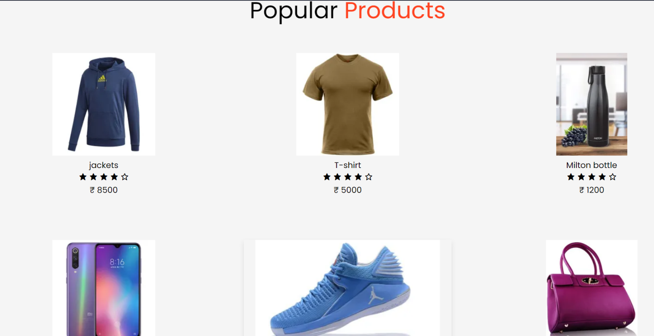

Veiw-2

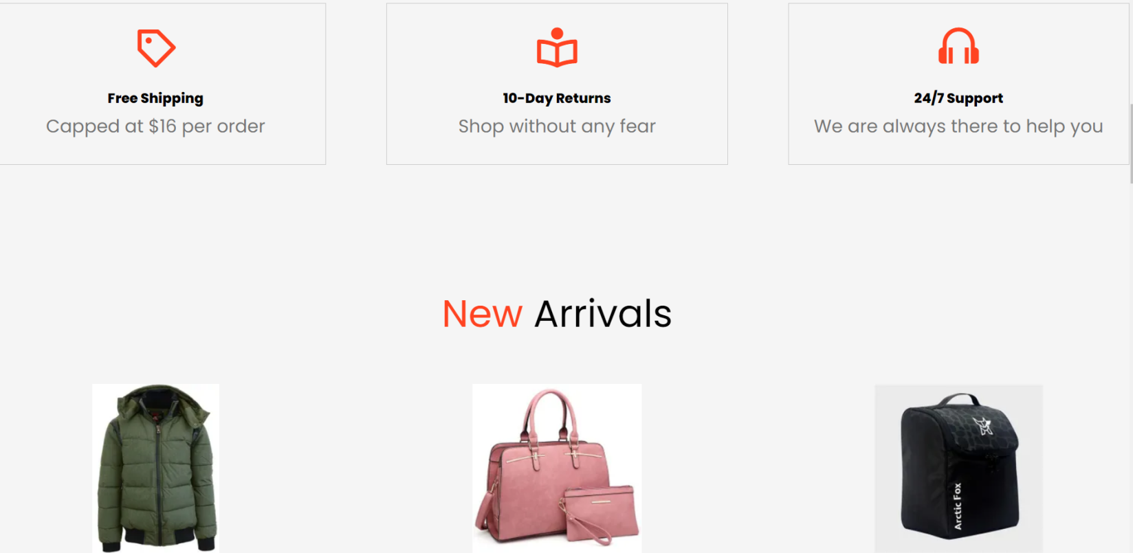

Contact us page

SOURCE CODE-:

<HTML>

**<!**DOCTYPE *html***>**

**<**html**>**

**<**head**>**

**<**link

*rel*="stylesheet"

*href*=

"https://maxcdn.bootstrapcdn.com/bootstrap/4.4.1/css/bootstrap.min.css"

**/>**

**<**link

*rel*="stylesheet"

*href*=

"https://cdnjs.cloudflare.com/ajax/libs/font-awesome/4.7.0/css/font-awesome.min.css"

**/>**

**<**link *rel*="stylesheet" *href*="contact us.css" **/>**

**</**head**>**

**<**body**>**

**<**section *id*="last"**>**

***<!--*** heading ***-->***

**<**div *class*="full"**>**

**<**h3**>**Drop a Message**</**h3**>**

**<**div *class*="lt"**>**

***<!--*** form starting  ***-->***

**<**form *class*="form-horizontal"

*method*="post" *action*="contact.php"**>**

**<**div *class*="form-group"**>**

**<**div *class*="col-sm-12"**>**

***<!--*** name  ***-->***

**<**input

*type*="text"

*class*="form-control"

*id*="name"

*placeholder*="NAME"

*name*="name"

*value*=""

**/>**

**</**div**>**

**</**div**>**

**<**div *class*="form-group"**>**

**<**div *class*="col-sm-12"**>**

***<!--*** email  ***-->***

**<**input

*type*="email"

*class*="form-control"

*id*="email"

*placeholder*="EMAIL"

*name*="email"

*value*=""

**/>**

**</**div**>**

**</**div**>**

***<!--*** message  ***-->***

**<**textarea

*class*="form-control"

*rows*="10"

*placeholder*="MESSAGE"

*name*="message"**>**

**</**textarea**>**

**<**button

*class*="btn btn-primary send-button"

*id*="submit"

*type*="submit"

*value*="SEND"**>**

**<**i *class*="fa fa-paper-plane"**></**i**>**

**<**span *class*="send-text"**>**SEND**</**span**>**

**</**button**>**

**</**form**>**

***<!--*** end of form ***-->***

**</**div**>**

***<!--*** Contact information ***-->***

**<**div *class*="rt"**>**

**<**ul *class*="contact-list"**>**

**<**li *class*="list-item"**>**

**<**i *class*="fa fa-map-marker fa-1x"**>**

**<**span *class*="contact-text place"**>**

             your address :- bh-657  - vasant colony , sector:

             phugwara  11411

**</**span**>**

**</**i**>**

**</**li**>**

**<**li *class*="list-item"**>**

**<**i *class*="fa fa-envelope fa-1x"**>**

**<**span *class*="contact-text gmail"**>**

**<**a *href*="mailto:yourmail@gmail.com" *title*="Send me an email"**>**

          shoppit234email@gmail.com**</**a**>**

**</**span**>**

**</**i**>**

**</**li**>**

**<**li *class*="list-item"**>**

**<**i *class*="fa fa-phone fa-1x"**>**

**<**span *class*="contact-text phone"**>**

                  (033) 12345678

**</**span**>**

**</**i**>**

**</**li**>**

**</**ul**>**

**</**div**>**

**</**div**>**

**</**section**>**

**</**body**>**

**</**html**>**

<CSS>

*#last*{

    width: 100%;

    height: **auto**;

    justify-content: **center**;

    background-color: **#ffb3b3**;

    }

*.full*{

    width: 80%;

    display: **inline-block**;

    margin:2%;

    margin-left: 10%;

    text-align: **center**;

    background-color: **black**;

    color: **white**;

    border:15px **solid** **orange**;

    border-radius: 5px;

    margin-bottom: 8%;

    margin-top: 8%;

    }

*.full* h3{

    font-size: 2rem;

    display:**block**;

    margin: 2%;

    margin-bottom: 0;

    }

*.lt*{

    padding: 2%;

    margin: 2%;

    }

*.rt*{

    padding: 2%;

    margin: 2%;

    }

*.lt* textarea{

    width: 94%;

    margin-left: 2.8%;

    }

    button{

    margin: 2%;

    }

*.btn-primary*{

    background-color: **black**;

    border: 2px **solid** **white**;

    border-radius: 5%;

    }

*.list-item*{

    margin-bottom: 2%;

    list-style-type: **none**;

    }

*.list-item* span{

    margin-left: 10px;

    font-size: 1.4rem;

    }

*.list-item* a{

    color: **white**;

    display: **inline-block**;

    }

*.list-item* a*:hover*{

    text-decoration: **underline**;

    }

*.form-control*{

    background-color: **black**;

    }

*@media* **screen** and (min-width: 770px){

*.full*{

        width: 70%;

        margin-left: 15%;

    }

*.lt* textarea{

    width: 95%;

    margin-left: 2.4%;

    }

    }

*@media* **screen** and (min-width: 1100px){

*.full*{

        width: 65%;

        margin-left: 17%;

        margin-top: 5%;

    }

*.lt*{

        width: 55%;

        display: **inline-block**;

        float: **left**;

        margin-right: 0;

    }

*.rt*{

        width: 35%;

        display: **inline-block**;

        margin-left: 0;

    }

*.list-item*{

    margin-bottom: 10%;

    }

*.contact-list*{

        margin-top: 22%;

        padding-right: 8%;

    }

*.fa-envelope*, *.gmail*{

        display: **inline-block**;

        width: **auto**;

    }

    }

RESULT/OUTPUT:-

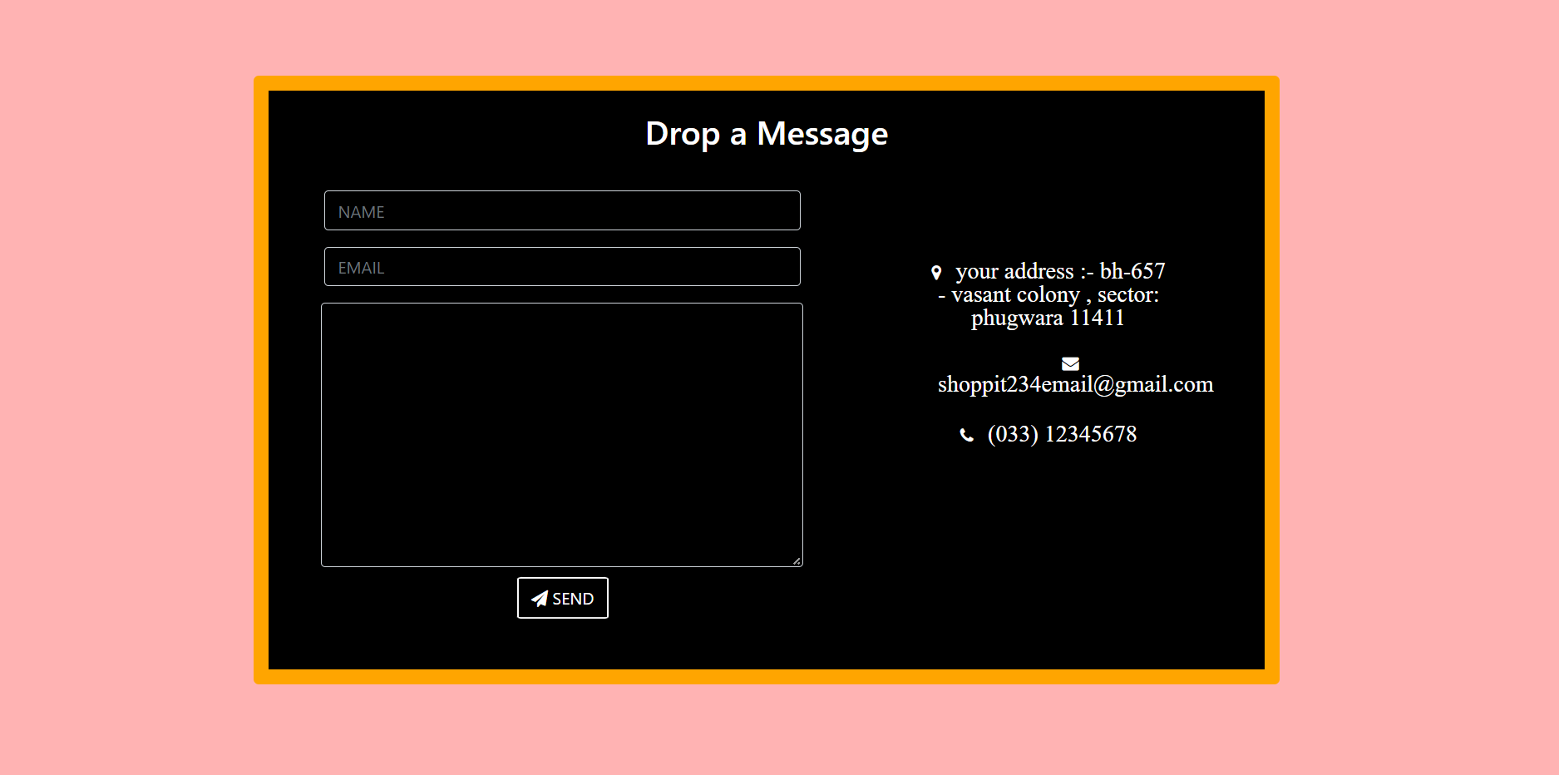

CART PAGE //

SOURCE CODE :-

<HTML>

**<**html**>**

**<**head**>**

**<**title**>** cart**</**title**>**

**</**head**>**

**<**link *rel*="stylesheet" *href*="lo.css"

<body**>**

**<**div *class*="container"**>**

**<**div *class*="payment_details"**>**

**<**h1**>**Payment Information**</**h1**>**

**<**div *class*="details_card"**>**

**<**div *class*="name_address"**>**

**<**div *class*="first_lastName"**>**

**<**input *type*="text" *placeholder*="First Name" **/>**

**<**input *type*="text" *placeholder*="Last Name" **/>**

**</**div**>**

**<**div *class*="address"**>**

**<**input *type*="text" *onkeyup*="change()" *id*="put" *placeholder*="Address" **/>**

**<**input *type*="number" *placeholder*="Pincode" **/>**

**<**input *type*="text" *placeholder*="Country" **/>**

**</**div**>**

**</**div**>**

**<**h1**>**Shipping Details**</**h1**>**

**<**div *class*="shipping_card"**>**

**<**div *class*="new_card"**>**

**<**h4**>**Same as personal**</**h4**>**

**<**p *id*="output"**>**Lovely professional university , Phagwara, Punjab

**</**p**>**

**<**p**>**11411**</**p**>**

**</**div**>**

**</**div**>**

**<**div *class*="proced_payment"**>**

**<**a *href*=""**>**Procced to payment**</**a**>**

**</**div**>**

**</**div**>**

**</**div**>**

**<**div *class*="order_summary"**>**

**<**h1**>**Order Summary**</**h1**>**

**<**div *class*="summary_card"**>**

**<**div *class*="card_item"**>**

**<**div *class*="product_img"**>**

**<**img *src*="images/milton.webp" *alt*="" **/>**

**</**div**>**

**<**div *class*="product_info"**>**

**<**h1**>**MILTON BOTTLE**</**h1**>**

**<**p**>**MILTON -S213**</**p**>**

**<**div *class*="close-btn"**>**

**<**i *class*="fa fa-close"**></**i**>**

**</**div**>**

**<**div *class*="product_rate_info"**>**

**<**h1**>**$ 200**</**h1**>**

**<**span *class*="pqt-minus"**>**-**</**span**>**

**<**span *class*="pqt"**>**1**</**span**>**

**<**span *class*="pqt-plus"**>**+**</**span**>**

**</**div**>**

**</**div**>**

**</**div**>**

**<**div *class*="card_item"**>**

**<**div *class*="product_img"**>**

**<**img *src*="images/headphone.webp" *alt*="" **/>**

**</**div**>**

**<**div *class*="product_info"**>**

**<**h1**>**BOAT HEADPHONES**</**h1**>**

**<**p**>**BOAT - Bat32**</**p**>**

**<**div *class*="close-btn"**>**

**<**i *class*="fa fa-close"**></**i**>**

**</**div**>**

**<**div *class*="product_rate_info"**>**

**<**h1**>**$ 160**</**h1**>**

**<**span *class*="pqt-minus"**>**-**</**span**>**

**<**span *class*="pqt"**>**1**</**span**>**

**<**span *class*="pqt-plus"**>**+**</**span**>**

**</**div**>**

**</**div**>**

**</**div**>**

**<**hr **/>**

**<**div *class*="order_price"**>**

**<**p**>**Order summary**</**p**>**

**<**h4**>**$400**</**h4**>**

**</**div**>**

**<**div *class*="order_service"**>**

**<**p**>**Additional Service**</**p**>**

**<**h4**>**$10**</**h4**>**

**</**div**>**

**<**div *class*="order_total"**>**

**<**p**>**Total Amount**</**p**>**

**<**h4**>**$370**</**h4**>**

**</**div**>**

**</**div**>**

**</**div**>**

**</**div**>**

**</**body**>**

**</**html**>**

<CSS>

* {

    margin: 0;

    padding: 0;

    box-sizing: **border-box**;

    font-family: "Nunito", **sans-serif**;

  }

  h1 {

    font-size: 16px;

    margin: 5px;

  }

*.container* {

    width: 100%;

    height: 92vh;

    display: **flex**;

    justify-content: **space-evenly**;

    align-items: **center**;

    background-color: **#f9fafc**;

  }

***/\****

  Payment Information card

***\*/***

*.details_card* {

    width: 700px;

    height: 400px;

    box-shadow: 0 0 5px 0 rgba(0, 0, 0, 0.2);

    border-radius: 8px;

    padding: 10px;

    background-color: **#fff**;

  }

***/\****

  Order Summary Card

***\*/***

*.summary_card* {

    background-color: **#fff**;

    width: 350px;

    height: 400px;

    box-shadow: 0 0 5px 0 rgba(0, 0, 0, 0.2);

    border-radius: 8px;

    padding: 10px;

  }

*.card_item* {

    display: **flex**;

    position: **relative**;

    margin: 10px 0;

  }

*.close-btn* {

    position: **absolute**;

    right: 10px;

    top: 5px;

  }

*.card_item* *.product_img* img {

    height: 80px;

    margin-right: 20px;

    width: 70px;

    border-radius: 5px;

  }

*.product_info* h1 {

    font-size: 20px;

    color: **#1e212d**;

    margin: 5px 0;

  }

*.product_info* p {

    color: **#a1a1a1**;

    font-size: 14px;

  }

*.product_rate_info* {

    display: **flex**;

    margin: 5px 0;

    align-items: **center**;

    justify-content: **space-between**;

  }

*.pqt* {

    font-size: 20px;

    line-height: 30px;

    width: 30px;

    text-align: **center**;

  }

*.pqt-plus*,

*.pqt-minus* {

    background: **#fcfcfc**;

    border: **none**;

    font-size: 20px;

    height: 100%;

    padding: 0 15px;

  }

*.pqt-plus:hover*,

*.pqt-minus:hover* {

    background: **#53b5aa**;

    color: **#fff**;

    cursor: **pointer**;

  }

*.pqt-plus* {

    line-height: 30px;

  }

*.pqt-minus* {

    line-height: 30px;

  }***/\****

*.pqt-plus* {

    line-height: 30px;

  }

*.pqt-minus* {

    line-height: 30px;

  }

***/\****

  Order price & total

***\*/***

*.order_price*,

*.order_service*,

*.order_total* {

    display: **flex**;

    justify-content: **space-between**;

    padding: 10px;

  }

*.order_price* p,

*.order_service* p {

    color: **#a1a1a1**;

  }

*.order_total* p {

    font-weight: 600;

  }

  input {

    outline: 0;

    background: **#f2f2f2**;

    border-radius: 4px;

    width: 100%;

    border: 0;

    caret-color: **#4f5d7e**;

    margin: 10px 15px;

    padding: 15px 20px;

    box-sizing: **border-box**;

    font-size: 14px;

  }

*.first_lastName*,

*.shipping_card*,

*.address* {

    display: **flex**;

    justify-content: **space-between**;

    margin: 10px 0;

  }

*.new_card* {

    width: 100%;

    height: 100px;

    border: 2px **solid** **#53b5aa**;

    padding: 10px;

    margin: 10px;

    border-radius: 10px;

  }

*.add_savedcard* {

    width: 100%;

    height: 100px;

    border: 2px **solid** **#a1a1a1**;

    padding: 10px;

    margin: 10px;

    border-radius: 10px;

  }

*.proced_payment* a {

    padding: 10px 20px;

    width: 200px;

    border: 2px **solid** **#f5f5f5**;

    background-color: **#53b5aa**;

    color: **#000**;

    margin-left: 10px;

    cursor: **pointer**;

    text-decoration: **none**;

  }

  footer {

    background-color: **#000**;

    color: **#fff**;

    height: 50px;

    text-align: **center**;

  }

  footer a {

    text-decoration: **none**;

    color: **#fff**;

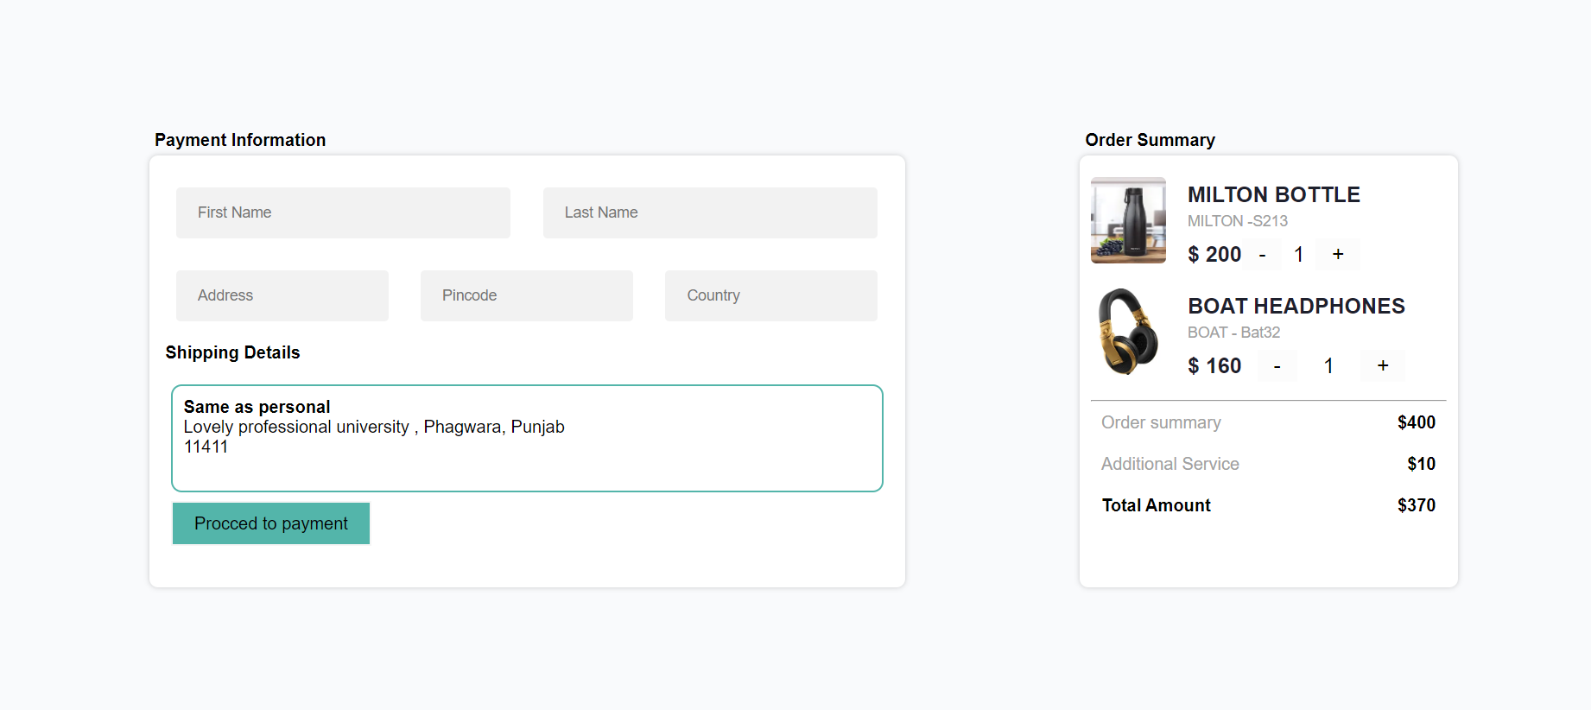

**RESULT/OUTPUT:-**

CONCLUSION



We hope and we wish that this document will help you to understand about our minimalist but attractive project as I had tried something different from usual.

I learned a lot of new skills thanks to this project which made me understand basic concepts of tags and how to apply them…….

THANK YOU VERY MUCH TO ALL….